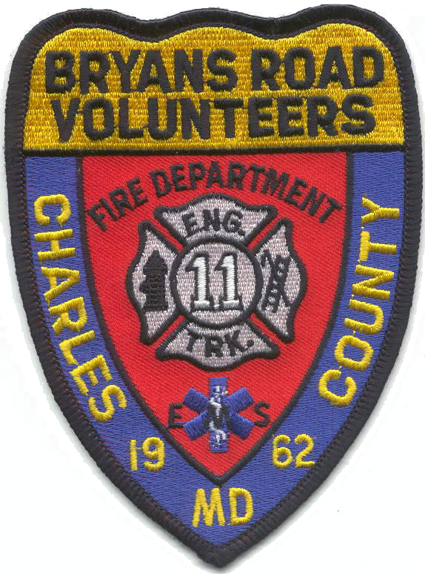
Bryans Road
Volunteer Fire Dept. & Rescue Squad, Inc.

P. O. Box 111, BRYANS ROAD, MARYLAND 20616

It is with great sadness and a heavy heart that the Bryans Road Volunteer Fire Department and Rescue Squad Inc., announces the passing of Life Member William Warren Atchison, better known as Mush to his friends. Mush passed away on Wednesday 8 March 2023 after a long battle with liver cancer.

Mush joined Bryans Road VFD & RS in 1969 at the age of 16. He was recently recognized for 50 LOSAP years of service to the citizens of Charles County. Overall he had a total of 54 years of service in our department. He also spent time as a member of Indian Head, Potomac Heights, and La Plata fire departments.

Mush was a Life Member who was regularly a top driver, served multiple terms as a Director on our Board, and sat on various committees. We are grateful for his dedicated service to our department and surrounding communities.

Arrangements are as follows:

Visitation at Station 11:
Bryans Road Fire Department and Rescue Squad
3099 Livingston Road, Bryans Road, MD 20616

Tuesday, March 14, 2023
1400 to 1600
1800 to 2000
Fireman’s Prayer @ 1900

In lieu of flowers, memorial donations can be sent in his name to:
Bryans Road VFD & Rescue Squad Inc.
PO Box 111, Bryans Road MD, 20616
